LAB REPORT实验报告
Lab Title | Data Files |  |  |  | Lab No. | 6
Stud. Name | Jiang Yunxiang | Major | CST |  | Class
Student ID | 2022102330 |  | Date | 3/31
Lab description/objectives:
Write a C program to read data from a text file containing multiple lines of text (created with Notepad, assuming that the maximum length of each line is 100 characters), and write the even-numbered lines of text into a file, and write the odd-numbered lines of text into another file. (Hints: use fgets() and fputs())
Source code:
（Paste the source code here）
#include <stdio.h>
#include <stdlib.h>
#define Max 1010
int main()
{
char Odd[Max];
char Even[Max];
FILE* file1, * file2, * file3;
file1 = fopen("ceshi.txt", "r");
file2 = fopen("oddfile.txt", "w");
file3 = fopen("evenfile.txt", "w");
while (fgets(Odd, 10, file1) != NULL) {
fgets(Even, 10, file1);
fputs(Even, file3);
fputs(Odd, file2);
}

fclose(file1);
fclose(file2);
fclose(file3);
return 0;
}
Program outputs:
（Paste the screenshot of program output here）

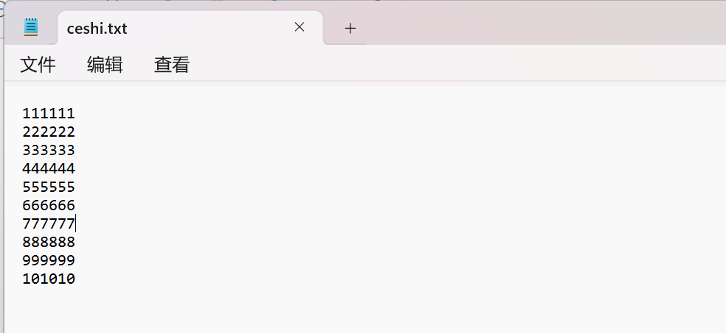
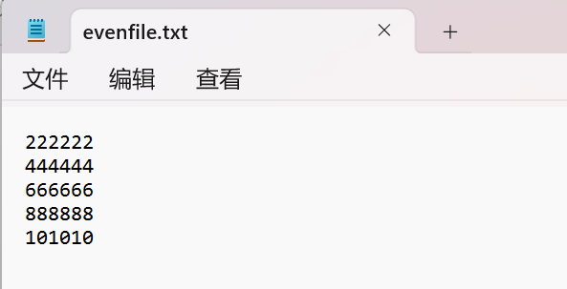
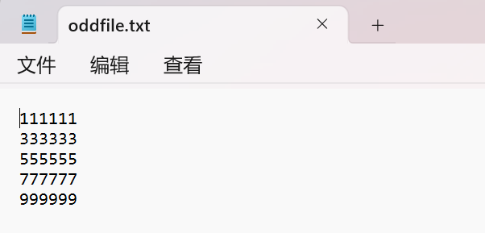
Discussion:
1．Most difficult parts
（What were the most difficult parts of your program to implement?）
Nope
2．Bugs and/or Errors
(List all the program bugs/errors you encountered and how you corrected them.)
Nope

